Mallu Sravana Sandhya Assessment-3

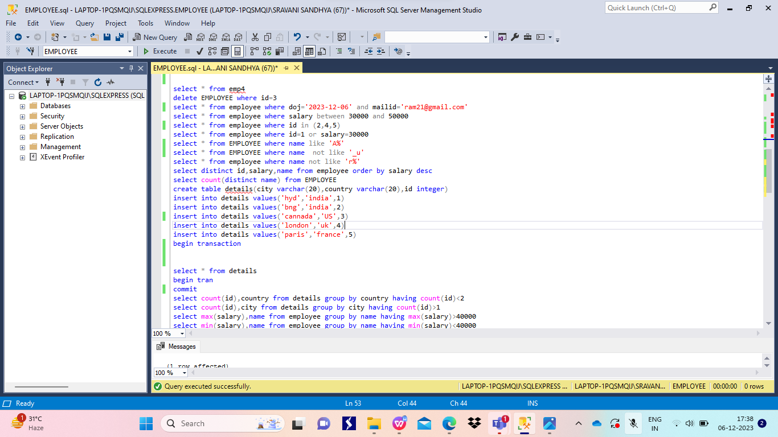

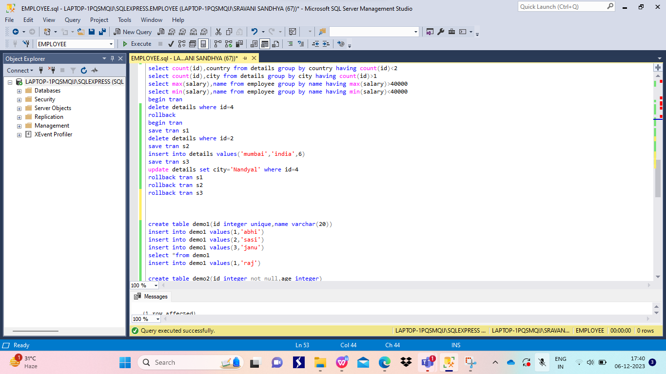

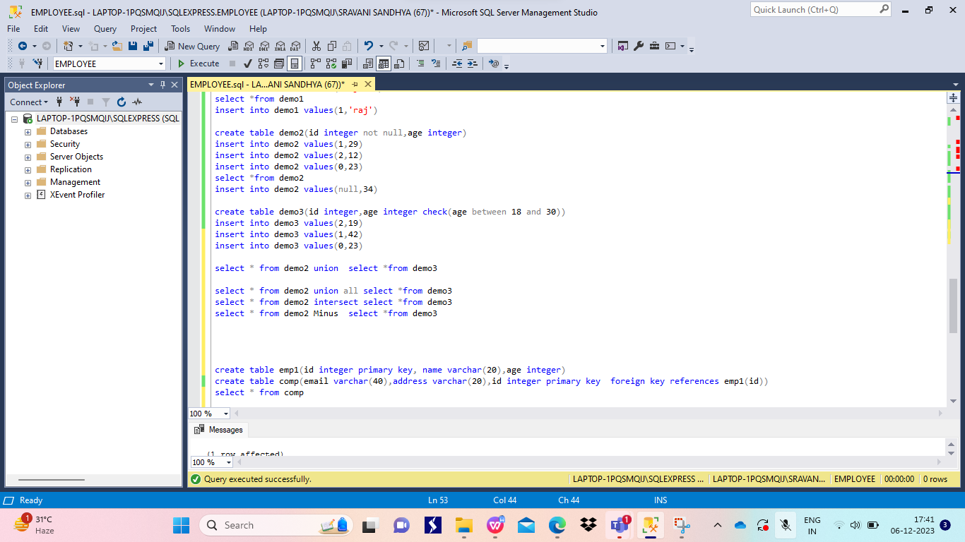

**Individual Screenshots**

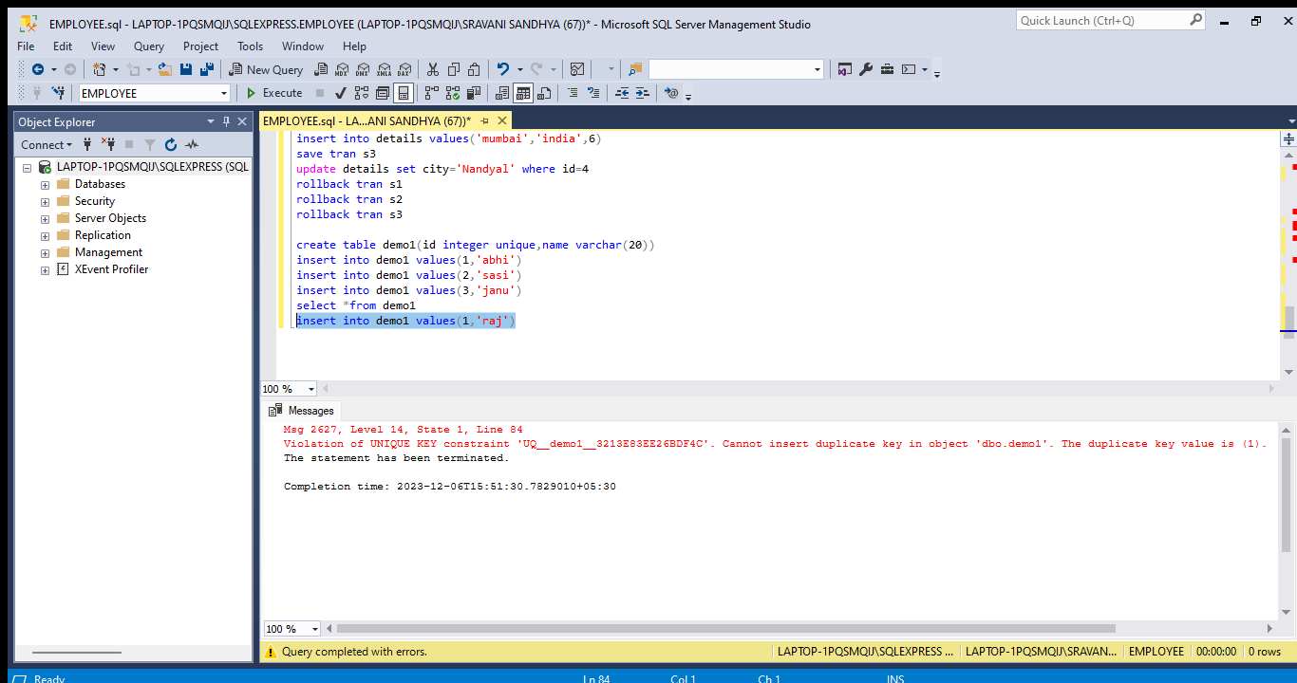

Column metion as unique while creating table it only allows unique values otherwise it raises error

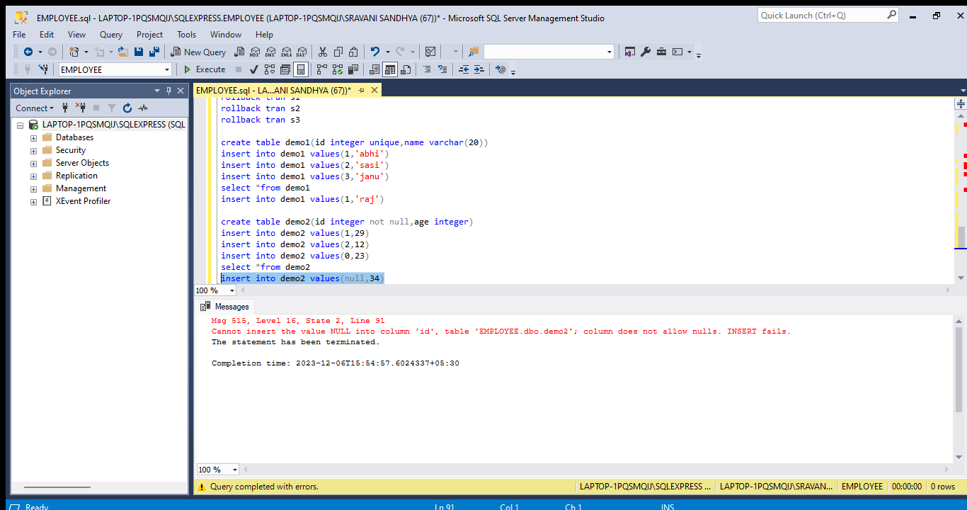

Column which is given as not null it does not allow null values

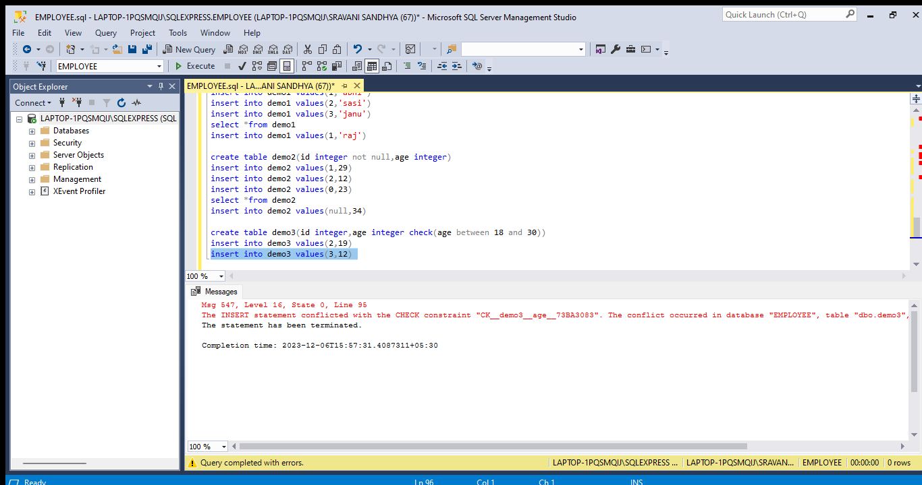

Check function verify the given input whether it satisfies the given condition or not

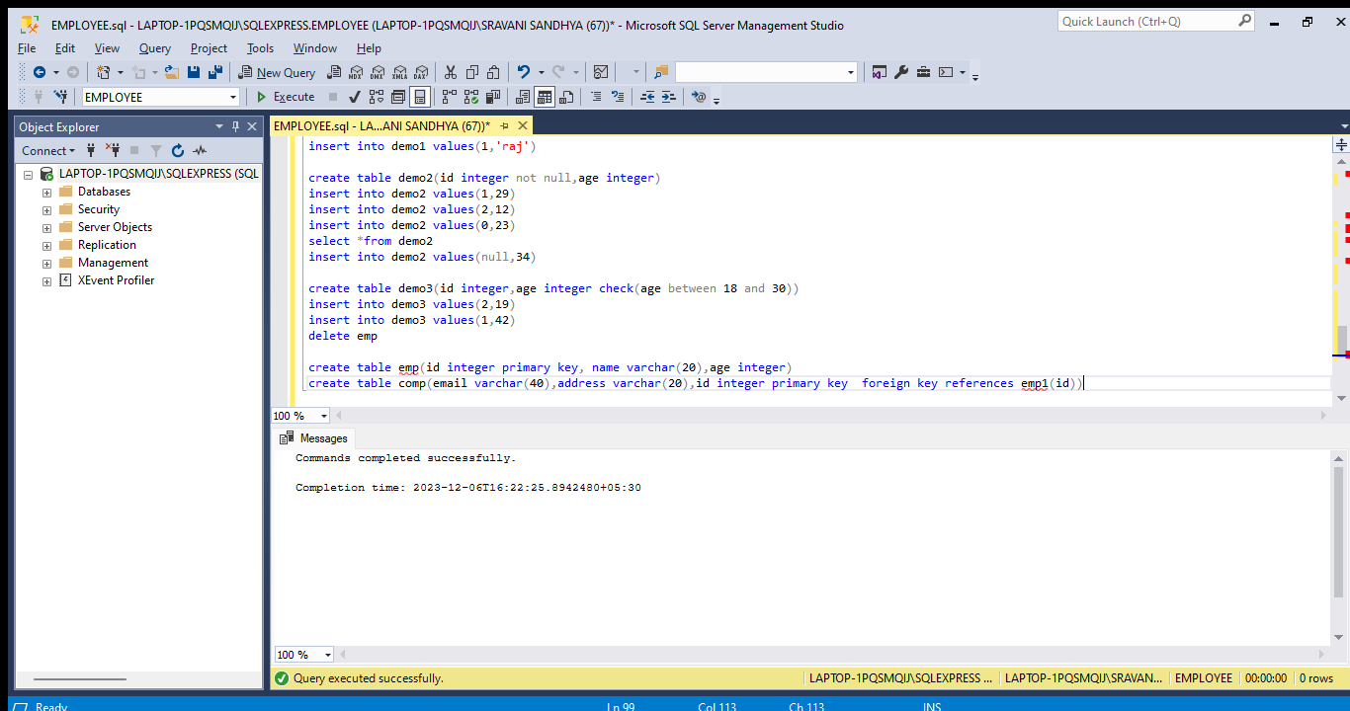

A table with primary key is created and related to other table as foreign key

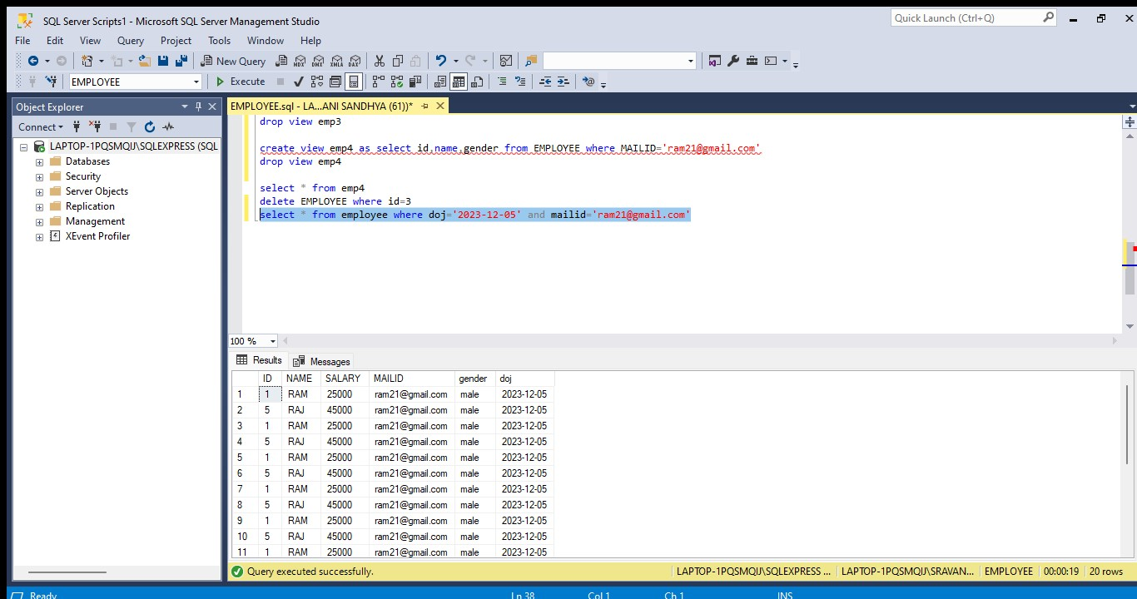

Using and operation which helps to fetch the data that satisfies both the conditions

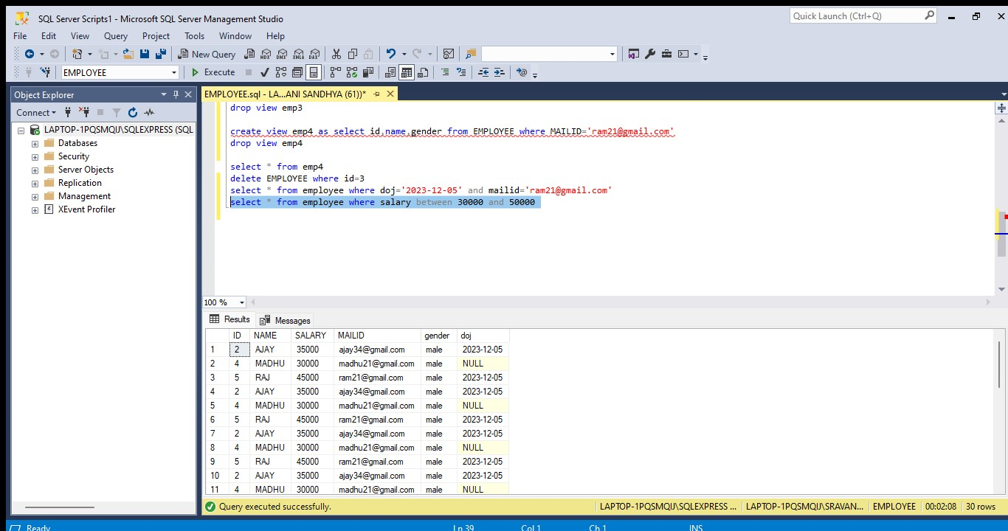

Between operation used to fetch the data which is in between the given values

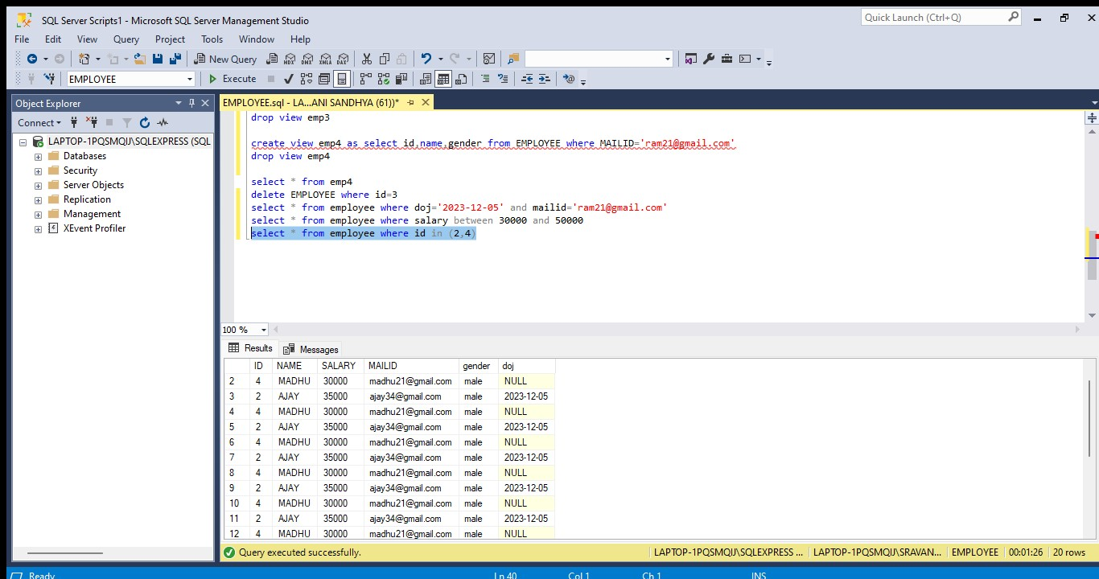

IN Operation used to get the data related to given ids

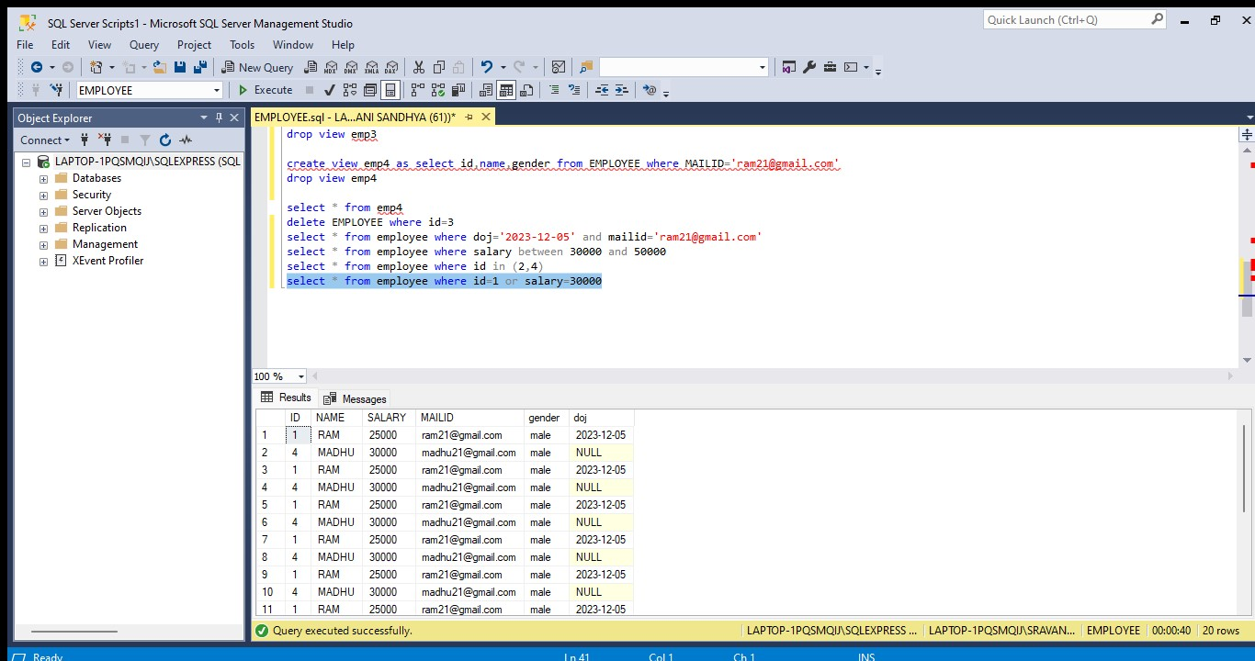OR operation used to fetch the data that satisfies either any of the conditions

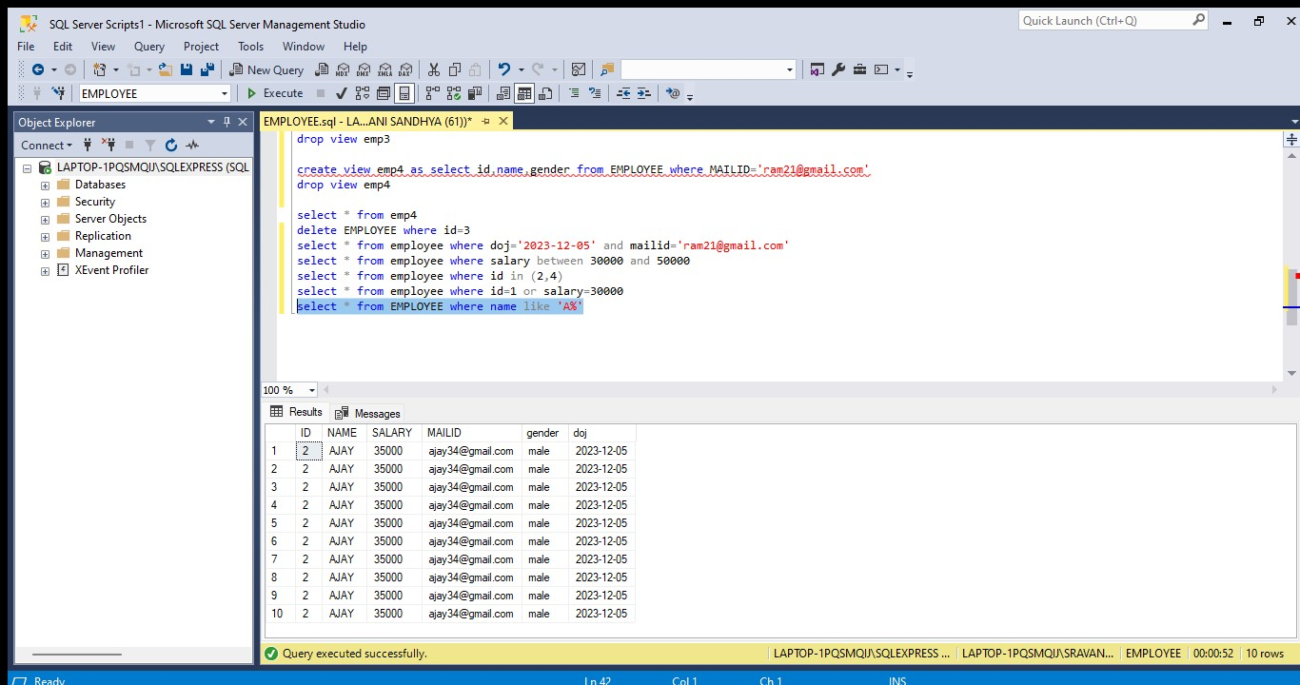

Like operation used to get data which starts with the given letter

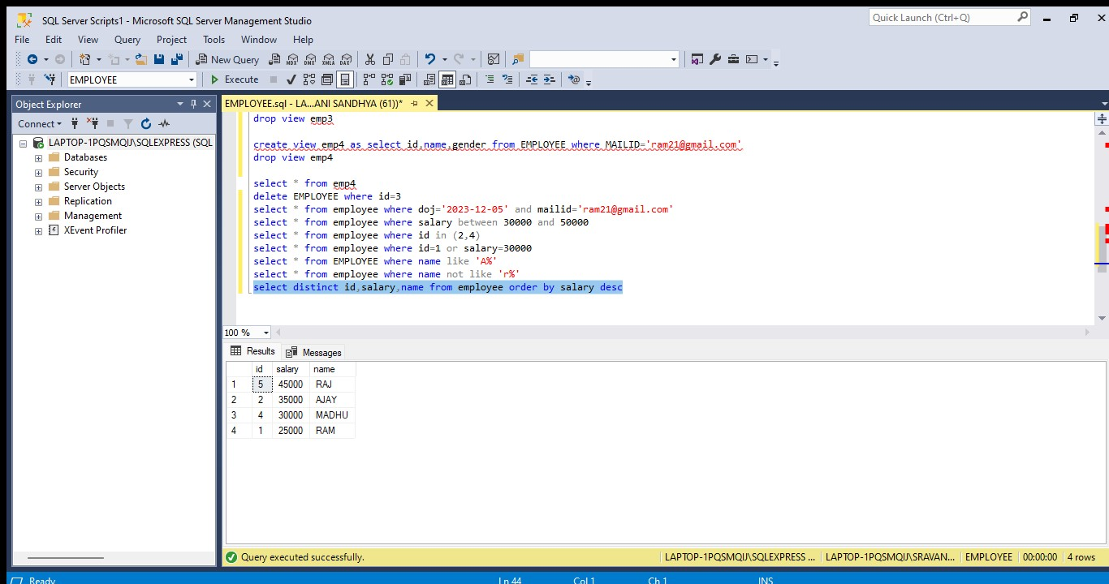

Orderby clause is used to arrange the data in numerical/alphabetical order

Desc --arranges in descending order

Asc--arranges in ascending order

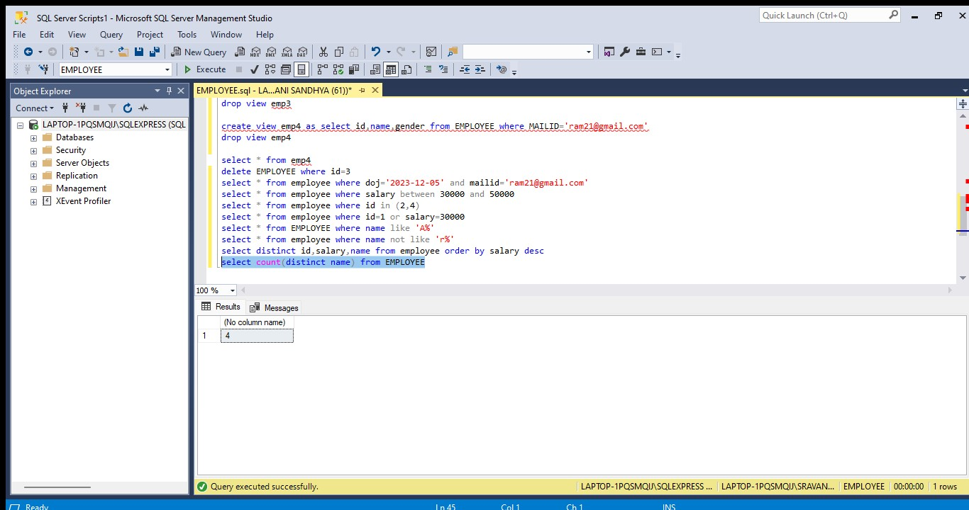

Count() function is used to count the records present in the table

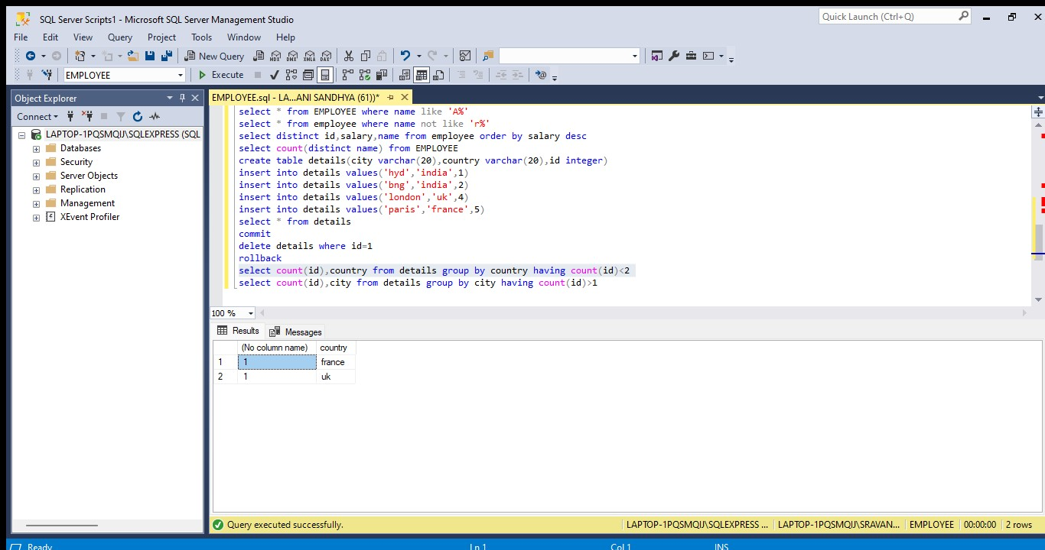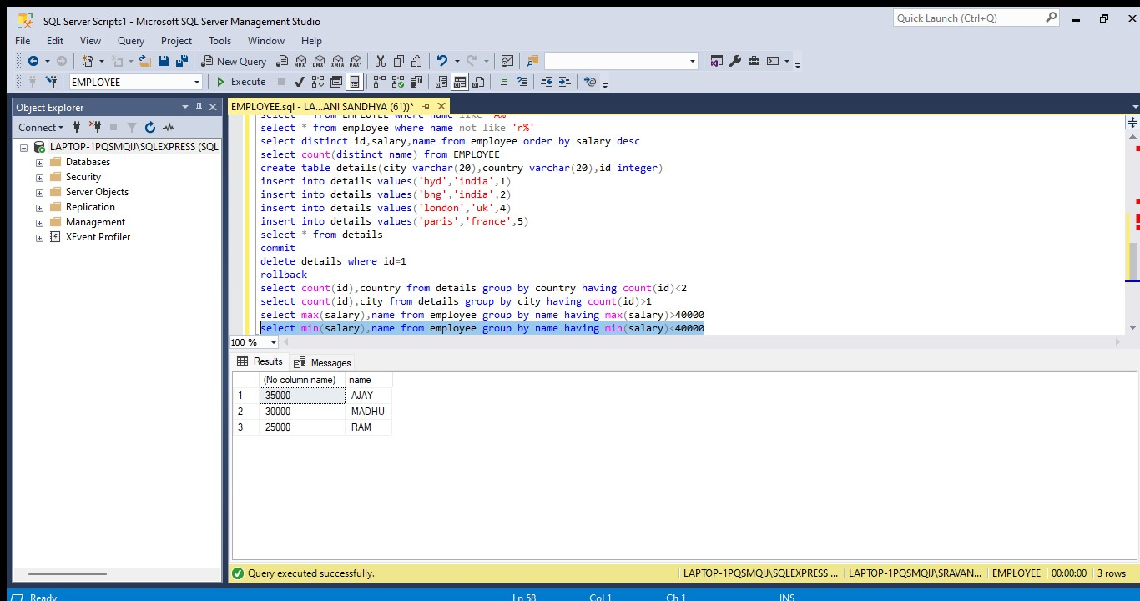

Group by clause is used to group the data present in the table based on aggregate function

Groupby clause can be used alone

Where as having clause is used only along with group by clause which helps to restrict data by some conditions in aggregate functions

**TCL COMMANDS**

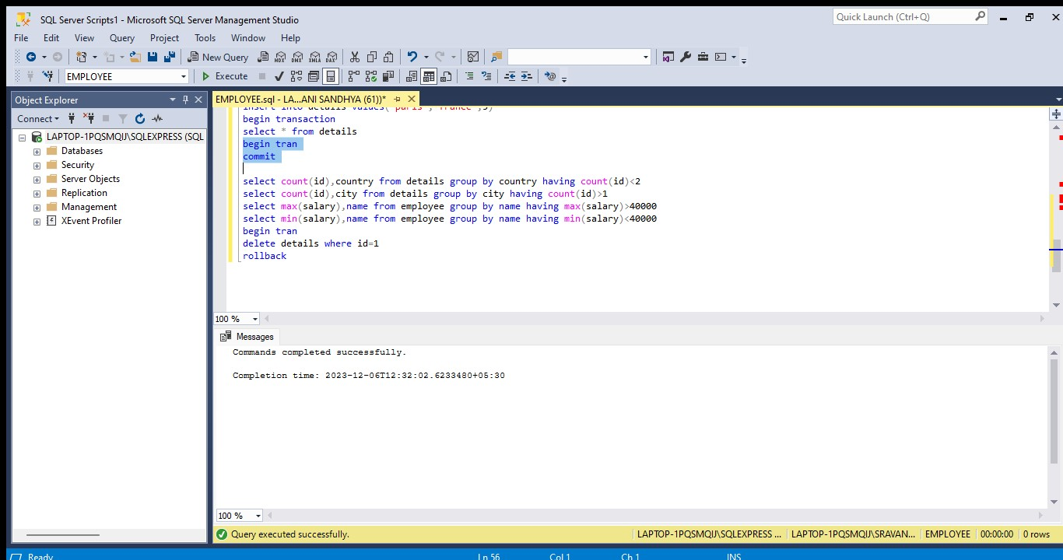

Commit is used to save the changes in the data base

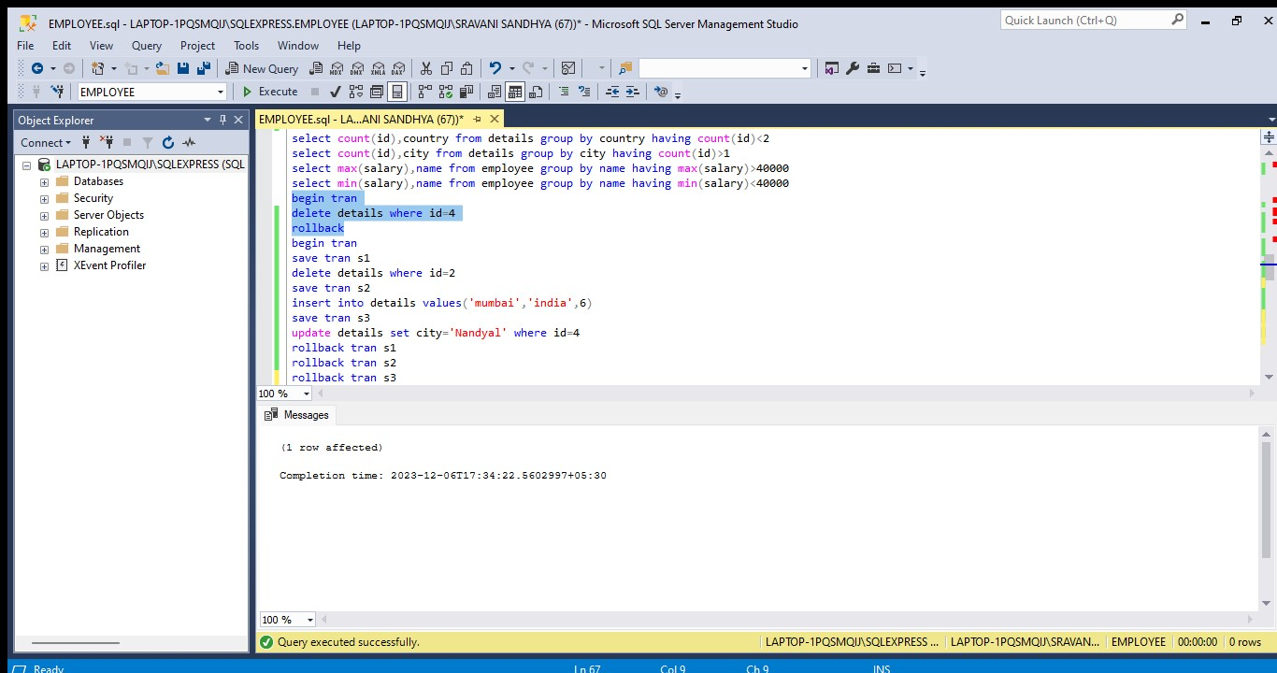

Rollback is used to undo the changes made until last commit

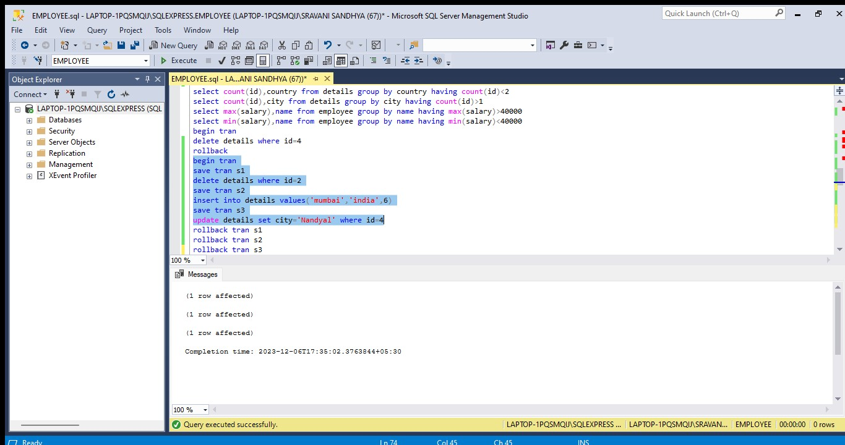

Savepoint is used to make changes and rollback to some extent